2_0 Adjacency List

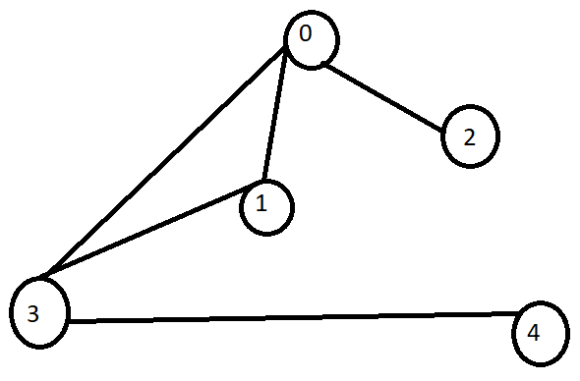

5 5
0 1
0 2
0 3
1 3
3 4

2_1 Adjacency List Implementation

#include<bits/stdc++.h>
using namespace std;
int main(){
int n, e;cin>>n>>e;
vector<int> adj_list[n]; // array of vector

while (e--)
{
int a, b;cin>>a>>b;
adj_list[a].push_back(b);
adj_list[b].push_back(a); // undirected
}
for (int i = 0; i < n; i++)
{
cout<<i<<"->";
for(auto val:adj_list[i]){
cout<<val<<" ";
}cout<<endl;
}

return 0;
}

// input:
// 5 5
// 0 1
// 0 2
// 0 3
// 1 3
// 3 4

// output:
// 0->1 2 3
// 1->0 3
// 2->0
// 3->0 1 4
// 4->3

2_3 Edge List
5 5
0 1
0 2
0 3
1 3
3 4

#include <bits/stdc++.h>
using namespace std;
int main()
{
int n, e;
cin >> n >> e;
vector<pair<int, int>> edge_list; // vector of pair

while (e--)
{
int a, b;
cin >> a >> b;
edge_list.push_back({a, b});
}

cout<<"Output :"<<endl;
for (pair<int, int> p : edge_list)
{
cout << p.first << " " << p.second<<endl;
}

return 0;
}

2_5 Comparison of 3 graph representations

Check 2 nodes connected :
adj_mat -> O(1)
adj_list -> O(n)
edge_list -> O(n)
check 2 nodes connected or not :
adj_mat
all the connected nodes with/from a node :
adj_list
only work with edges :
edge_list

2_6 Graph Visualization

https://csacademy.com/app/graph_editor/

2_7 Graph Traversal
Graph Traverse :
BFS
DFS

2_8 BFS Traversal theory

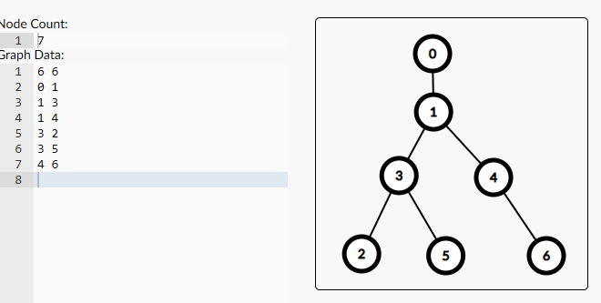
Input:
6 6
0 1
1 3
1 4
3 2
3 5
4 6

2_9 BFS traversal implementation
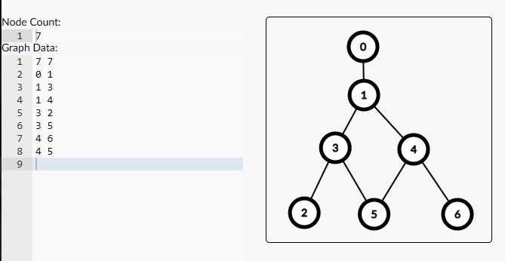
Input :
7 7
0 1
1 3
1 4
3 2
3 5
4 6
4 5

Code :
#include <bits/stdc++.h>
using namespace std;

vector<int> adj_list[1005];
bool vis[1005];

void bfs(int src)
{
queue<int> q;
q.push(src);
vis[src] = true;

while (!q.empty())
{
// node ber koro
int par = q.front();
q.pop();

// node niye kaj
cout << par << " ";

// childre push
for (int child : adj_list[par])
{
if(!vis[child])
q.push(child);
vis[child] = true;
}
}
}

int main()
{
int n, e;
cin >> n >> e;
while (e--)
{
int a, b;
cin >> a >> b;
adj_list[a].push_back(b);
adj_list[b].push_back(a);
}

bfs(0);

return 0;
}

2_11 Complexity Analysis of BFS

void bfs(int src)
{
q.push(src);
vis[src] = true;
while (!q.empty()) // O(V)
{
// node ber koro
int par = q.front();
q.pop();

// node niye kaj
cout << par << " ";

// children push
for (int child : adj_list[par]) // not depends on outer loop instead of inner condition . O(E)
{
if (!vis[child]) // this condition
q.push(child);
vis[child] = true;
}
}
}

O(v)
O(v+e)

v=vertex
e=edges

